
PROG7314
POE PART 2

Tinodiwanashe dzoro ST10402234
Naomie ELIMIE ST10303069
TAPIWA SANGO ST10276025

Table of Contents
Links 1
GitHub Link 1
YouTube Video (UI) 1
YouTube Video (API) 1
Public API URL 1
Screenshots 2
backend/src/app.js (API structure): 2
backend/src/db.js (database): 3-4
Replit Shell showing server listening message 4
curl POST to /api/routes (201 success) 4
curl GET to /api/routes (data persisted) 4
Replit deployment page with public URL 5
Postman hitting /api/routes on the public URL 5
Validation error response (400 + details) 6
npm test output showing 16 passed 6
GitHub Actions green 7
Firestore DB 7

Links
- GitHub Link: https://github.com/EMGPRS/prog7314-2026-poe-part-2-group-dzoro-tinodiwanashe.git
- YouTube Video (UI): https://youtu.be/tuKKk-QwPLA?si=qKNvswaAs3Ewg3uI
- YouTube Video (API): https://youtu.be/1AwAZhr4MCA
- Public API URL: https://navigo-apizip--t6102412.replit.app

Screenshots:

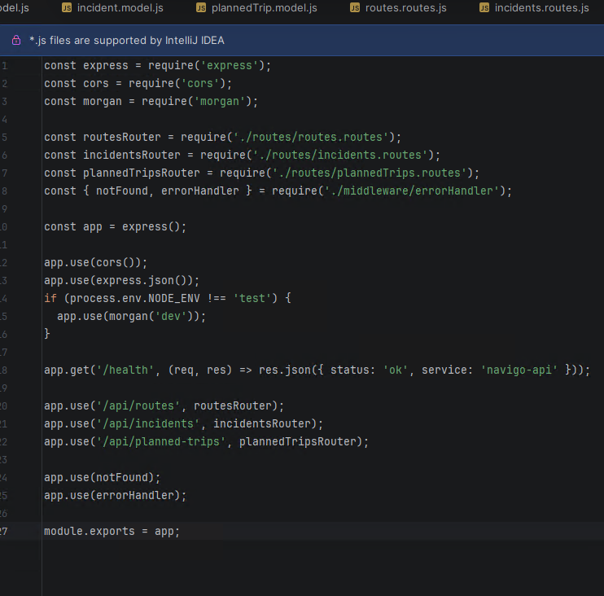
backend/src/app.js (API structure):

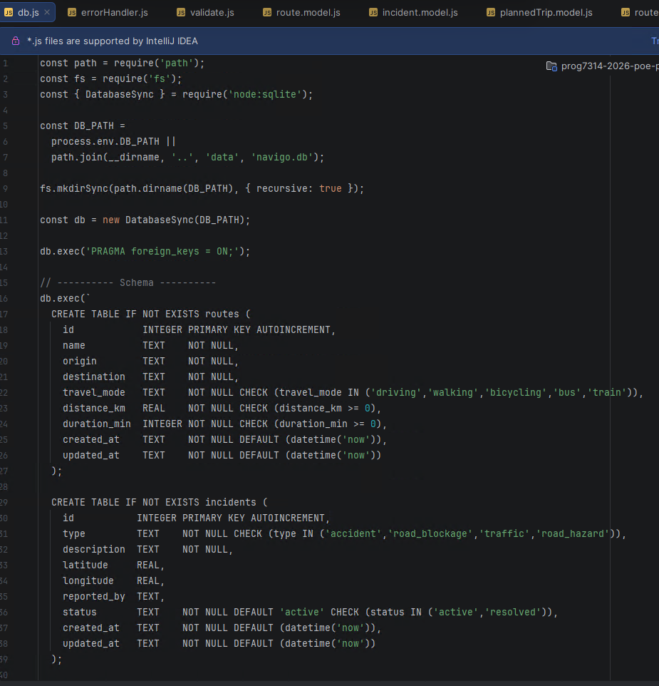
backend/src/db.js (database):
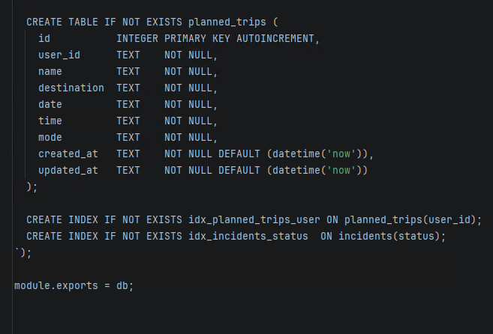

Replit Shell showing server listening message
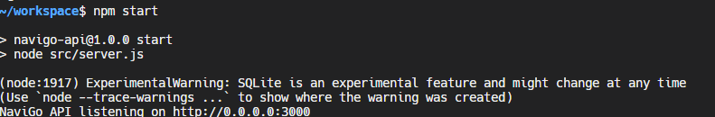

curl POST to /api/routes (201 success)
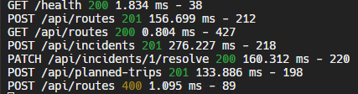

curl GET to /api/routes (data persisted)

Replit deployment page with public URL
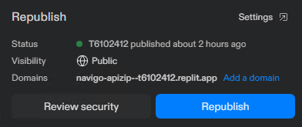

Postman hitting /api/routes on the public URL
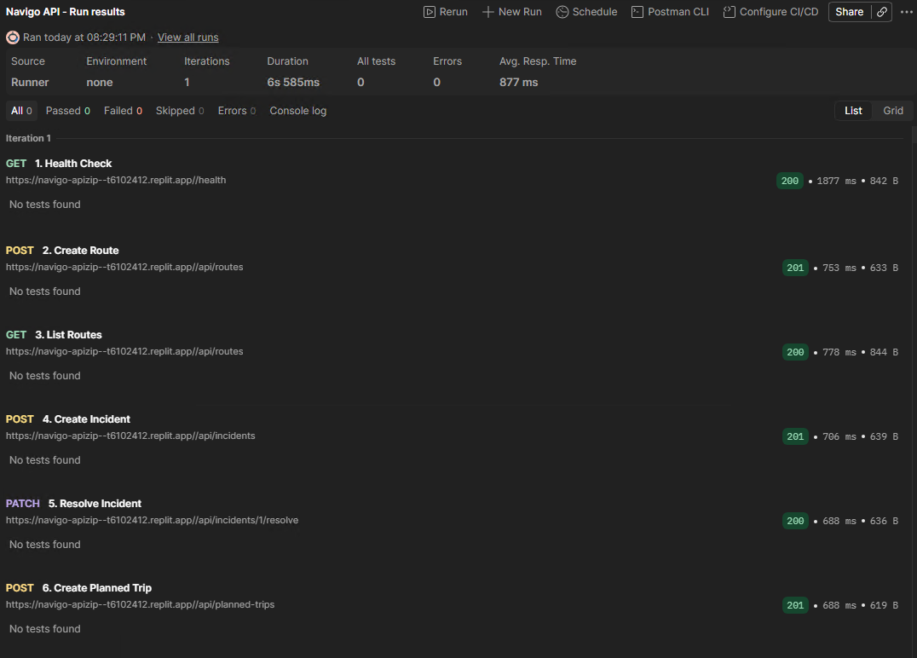
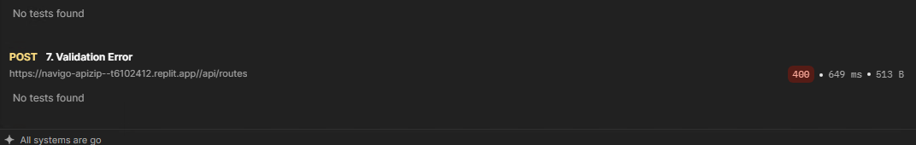

Validation error response (400 + details)
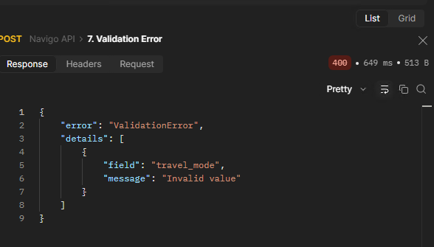

npm test output showing 16 passed
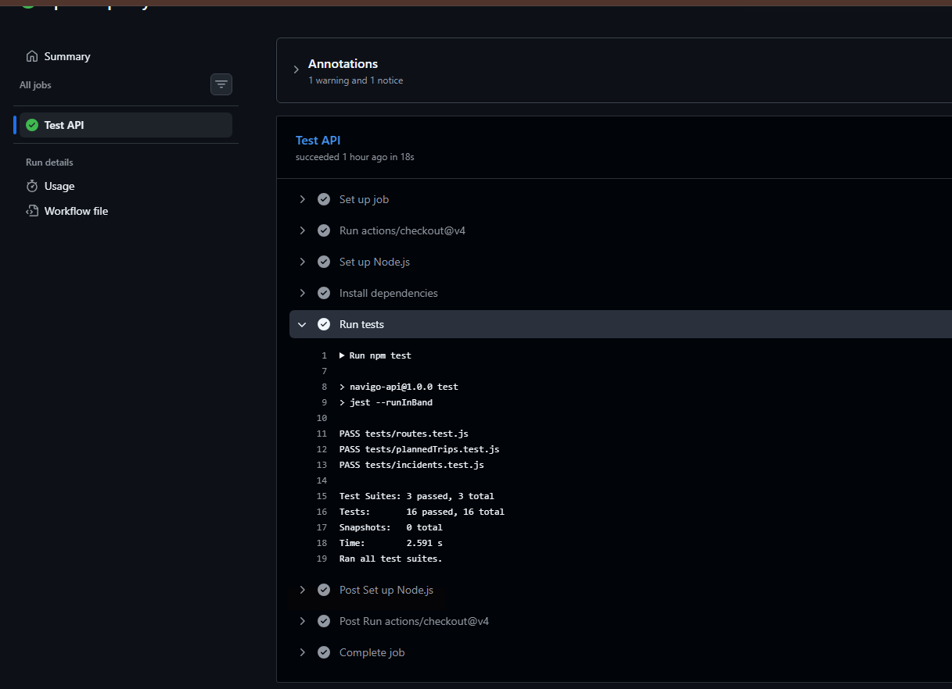

GitHub Actions green
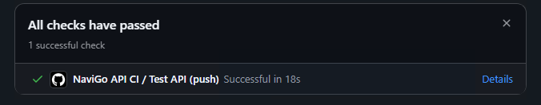

Firestore DB
